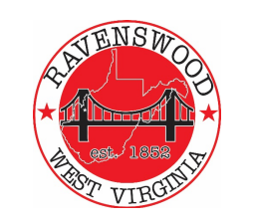

**City of Ravenswood**

**‘Special Call ‘Planning Commission Agenda**

**October 31, 2024 – 6p**

1. **Pledge of Allegiance**
2. **Roll Call – Ritchie, Akers, Casey, Fox, Greening, Salser, Cady, Carmichael –**
3. **Public Forum -**
4. **Building Permit(s) Status** 
   1. **Review Land Use Application – Variance Request** 
      1. **505 Mulberry Street**

1. **Land Use Code Revision**

* **Review of proposed Revised Land Use Code Documents**

**VII. Adjournment**