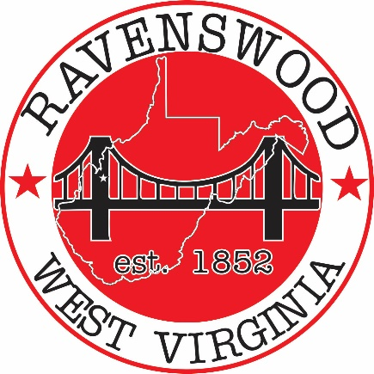

**Ravenswood City Council**

**Regular Meeting**

**Ravenswood Municipal Complex 1 Wall Street, 3rd Floor**

**Tuesday, June 21st, 2022 at 7:00pm**

**Stream Council Meeting Live on Facebook at** [**www.facebook.com/cityofravenswood**](http://www.facebook.com/cityofravenswood)

1. Pledge of Allegiance
2. Welcome - Call to order - Roll Call
3. Public Forum
4. Consent Agenda
   1. Approval of Prior Meeting Minutes 6/7/2022
5. Resolution – To consider and act upon approving Water and Sewer Project Monthly Invoices
6. To open bids for the Board of Parks and Recreation for The Great Bend Museum chimney restoration project
7. Update on McIntosh Bldg. and NYA Hall Restoration Project – Steve Cogar & Katrena Ramsey
8. Resolution – Appointment to the Ravenswood Building Commission
   1. Scott Bush
9. Ordinance – To consider and act upon the Phase I Marina and Recreation Bond (Second Reading)
10. To consider and act upon declaring an opening for the Ravenswood Maintenance Department
11. Next Proposed Meeting Date– Tuesday, July 5th, 2022 at 7:00pm Location: 1 Wall Street, 3rd Floor

(Ravenswood Municipal Complex)

1. Adjournment